Handout Dynamic simulation
In this example you will investigate the behavior of a circuit board in protective crushable foam packaging dropped at an angle onto a rigid surface. Your goal is to assess whether the foam packaging is adequate to prevent circuit board damage when the board is dropped from a height of 1 meter.
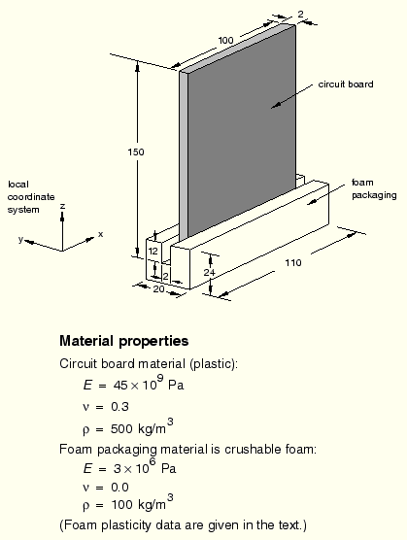

Preprocessing—creating the model with ABAQUS/CAE
Defining the model geometry
You will create three parts representing the packaging, the circuit board, and the floor. The chips will be represented using discrete point masses. You will also create a number of datum points to aid in positioning the part instances and the point masses.
To define the packaging geometry:
- The packaging is a three-dimensional solid structure. Create a three-dimensional, deformable part with an extruded solid base feature to represent the packaging; name the part Packaging. Use an approximate part size of 0.1, and sketch a 0.02 m × 0.024 m rectangle as the profile. Specify 0.11 m as the extrusion depth.
- From the main menu bar, select ShapeCutExtrude to create the cut in the packaging in which the circuit board will rest.
  - Select the left end of the packaging as the plane for the extruded cut. Select a vertical line on the packaging profile to be vertical and on the right in the sketching plane.
  - In the Sketcher, create a vertical construction line through the center of the packaging. Apply a fixed constraint to the construction line.
  - Sketch the profile of the cut. Use a Symmetry constraint to center the cut about the construction line and edit the dimensions of the cut profile so that it is 0.002 m wide and extends a distance of 0.012 m into the packaging.
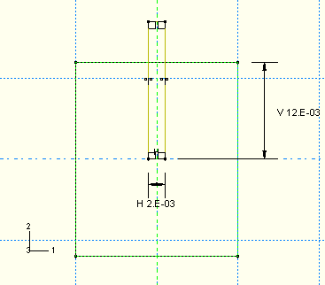
  - In the Edit Cut Extrusion dialog box that appears upon completion of the sketch, select Through All as the end condition and select the arrow direction representing a cut into the packaging.
- Create a datum point centered on the bottom face of the cut. This point will be used to position the board relative to the packaging.
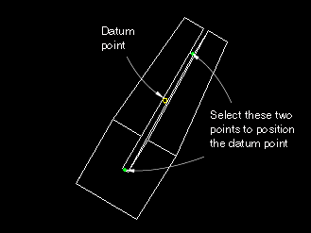
  - From the main menu bar, select ToolsDatum.
  - Accept the default selection of Point as the datum type and select Midway between 2 points as the method.
  - Select the two points centered on the bottom face at either end of the cut to be the two points between which the datum point will be created.
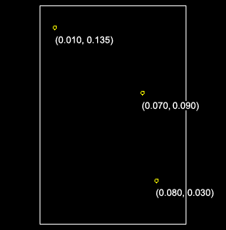
To define the circuit board geometry:
- The circuit board can be modeled as a thin, flat plate with chips attached to it. Create a three-dimensional, deformable planar shell to represent the circuit board; name the part Board. Use an approximate part size of 0.5, and sketch a 0.100 m × 0.150 m rectangle for the profile.
- Create the three datum points. These points will be used to position the chips on the board.
  - From the main menu bar, select ToolsDatum.
  - Accept the default selection of Point as the datum type, and select Offset from point as the method.
  - Select the bottom left corner of the board as the point from which to offset, and enter the coordinates for one of the points.
  - Repeat Step c to create the other two datum points.
To define the floor:
- The surface that the circuit board will impact is effectively rigid. Create a three-dimensional, discrete rigid planar shell to represent the floor; name the partFloor. Use an approximate part size of 0.5. The rigid surface should be large enough to keep any deformable bodies from falling off the edges.
- Sketch a 0.2 m × 0.2 m square as the profile. To simplify the positioning of parts in the assembly of the model, ensure that the center of the surface corresponds to point (0, 0) in the sketcher. This also corresponds to the origin of the global coordinate system.
- Assign a reference point at the center of the part.
Defining the material and section properties
The circuit board is assumed to be made of a PCB elastic material with a Young's modulus of 45 × 10⁹ Pa and a Poisson's ratio of 0.3. The mass density of the board is 500 kg/m³. Define a material named PCB with these properties.
The foam packaging material will be modeled using the crushable foam plasticity model. The elastic properties of the packaging include a Young's modulus of 3 × 10⁶ Pa and a Poisson's ratio of 0.0. The material density of the packaging is 100.0 kg/m³. Define a material named Foam with these properties; do not close the material editor.
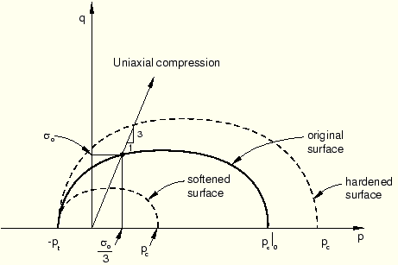
The yield surface of a crushable foam in the p–q (pressure stress–von Mises equivalent stress) plane is illustrated.
The initial yield behavior is governed by the ratio of initial yield stress in uniaxial compression to initial yield stress in hydrostatic compression, , and the ratio of yield stress in hydrostatic tension to initial yield stress in hydrostatic compression, . In this problem we have chosen the first data item to be 1.1 and the second data item (which is given as a positive value) to be 0.1.
Table 1. Foam hardening
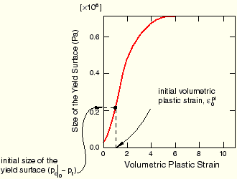
material data.
In the material editor, select MechanicalPlasticityCrushable Foam. Enter the yield stress ratios given above. Click Suboptions, select Foam Hardening, and enter the hardening data.
Yield stress in uniaxial compression (Pa) | Plastic strain
0.22000E6 | 0.0
0.24651E6 | 0.1
0.27294E6 | 0.2
0.29902E6 | 0.3
0.32455E6 | 0.4
0.34935E6 | 0.5
0.37326E6 | 0.6
0.39617E6 | 0.7
0.41801E6 | 0.8
0.43872E6 | 0.9
0.45827E6 | 1.0
0.49384E6 | 1.2
0.52484E6 | 1.4
0.55153E6 | 1.6
0.57431E6 | 1.8
0.59359E6 | 2.0
0.62936E6 | 2.5
0.65199E6 | 3.0
0.68334E6 | 5.0
0.68833E6 | 10.0
Define a homogeneous shell section named BoardSection that refers to the material PCB. Specify a thickness of 0.002 m, and assign this section definition to the part Board. Define a homogeneous solid section named FoamSection that refers to the material Foam. Assign this section definition to the part Packaging.
For the circuit board it is most meaningful to output stress results in the longitudinal and lateral directions, aligned with the edges of the board. Thus you need to specify a local material orientation for the circuit board mesh.

To specify a material orientation for the board:
- Double-click Board underneath the Parts container in the Model Tree.
- To define a datum coordinate system for the orientation:
  - From the main menu bar, select ToolsDatum.
  - Select CSYS as the type and 2 lines as the method.
  - In the Create Datum CSYS dialog box that appears, select a rectangular coordinate system and click Continue.
  - In the viewport, select the bottom horizontal edge of the board to be the local x-axis and the right vertical edge of the board to lie in the X–Y plane.
The datum coordinate system appears in yellow in the viewport.
- From the main menu bar of the Property module, select AssignMaterial Orientation. In the viewport select the circuit board. Select the datum coordinate system as the coordinate system. In the material orientation editor select Axis 3 as the shell surface normal and None as the additional rotation about that axis.
The material orientation appears on the board in the viewport. Click OK in the prompt area.
Creating the assembly
In the Model Tree, double-click Instances underneath the Assembly container and create a dependent instance of the floor.
The circuit board will be dropped at an angle.
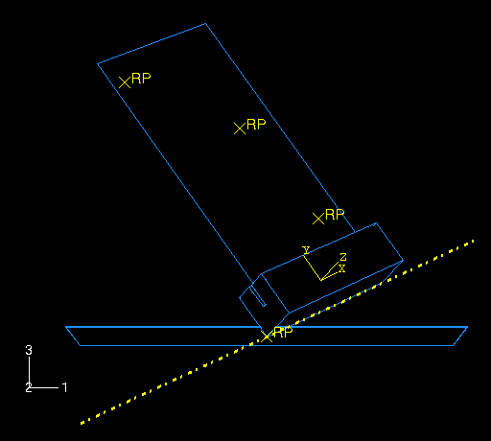
You will use the positioning tools in the Assembly module to position the packaging first; then you will position the board relative to the packaging. Finally, you will create a reference point at each datum point location of the board to represent the chips.
To position the packaging:
- From the main menu bar of the Assembly module, select ToolsDatum to create additional datum points that will help you position the packaging.
  - Select Point as the type, and select Enter coordinates as the method.
  - Create two datum points at (0, 0, 0) and (0.5, 0.707, 0.25).
  - Click the auto-fit tool to see both points in the viewport.
- In the Create Datum dialog box, select Axis as the type and 2 points as the method. Create a datum axis defined by the two datum points created in the previous step, selecting the point at (0.5, 0.707, 0.25) as the first point in the datum axis definition.
- Instance the packaging.
- Constrain the packaging so that the bottom edge aligns with the datum axis.
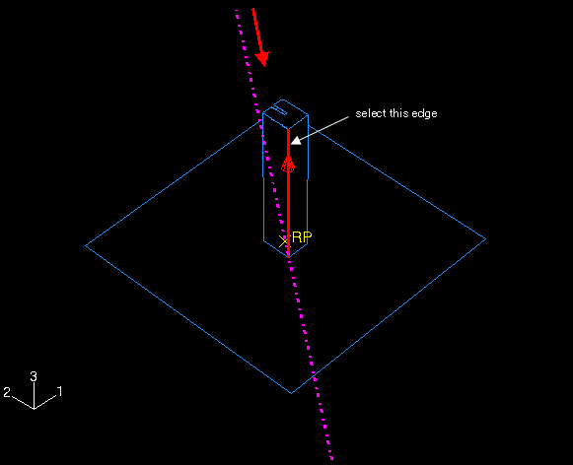
  - From the main menu bar, select ConstraintEdge to Edge.
  - Select the edge of the packaging as a straight edge of the movable instance.
Tip: To obtain a better view of the model, select ViewSpecify from the main menu bar and select Viewpoint as the method; enter(–1, –1, 1) for the viewpoint vector and (0, 0, 1) for the up vector.
  - Select the datum axis as the fixed instance.
  - If necessary, click Flip in the prompt area to reverse the direction of the arrow on the packaging; click OK when the arrows point in opposite directions.
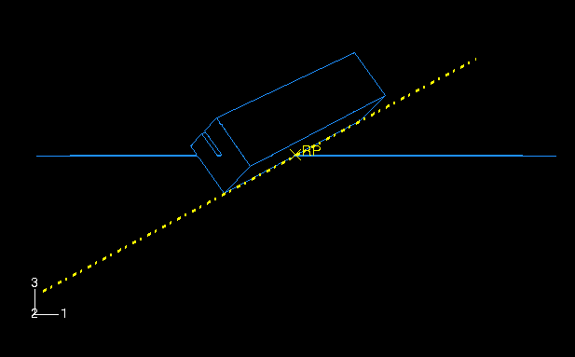
Tip: You may need to zoom out and rotate the model to see the arrow on the datum axis. The direction of this arrow depends on how you defined the axis initially; if the arrow on your axis points in the reverse direction of the one shown in the figure, the arrow on your packaging should also be opposite to the figure.
Note: ABAQUS/CAE stores position constraints as features of the assembly; if you make a mistake while positioning the assembly, you can delete the position constraints. Simply click mouse button 3 on the constraint you wish to delete in the list of Position Constraints items found underneath the Assembly container in the Model Tree, and select Delete from the menu that appears.
- Create a third datum point at (–0.5, 0.707, –0.5), and click the auto-fit tool again.
- In the Create Datum dialog box, select Plane as the type and Line and point as the method. Create a datum plane defined by the datum axis created earlier and the datum point created in the previous step.
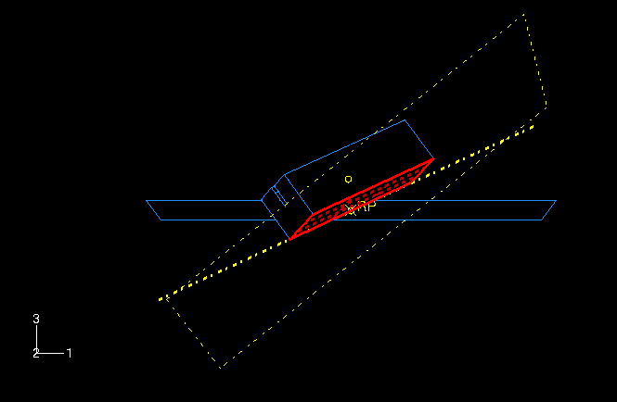
- Constrain the packaging so that the bottom face lies on the datum plane.
  - From the main menu bar, select ConstraintFace to Face.
  - Select the face of the packaging as a face of the movable instance.
  - Select the datum plane as the fixed instance.
  - If necessary, click Flip in the prompt area; click OK when both arrows point in the same direction.
  - Accept the default distance of 0.0 from the fixed plane.
- Finally, constrain the packaging to contact the floor at its center.
  - From the main menu bar, select ConstraintCoincident Point.
  - Select the lowest vertex of the packaging as a point on the movable instance, and select the reference point on the floor as a point on the fixed instance.

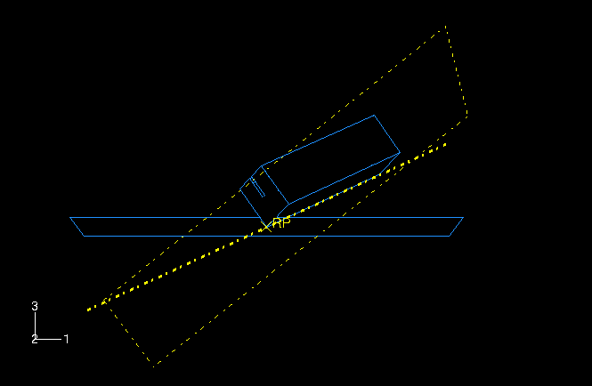
- Now, translate the floor slightly downward to ensure that there is no initial overclosure between the packaging and the floor.
  - Convert the relative position constraints to absolute constraints to avoid conflicts. From the main menu bar, select InstanceConvert Constraints. Select the packaging in the viewport, and click Done in the prompt area.
  - From the main menu bar, select InstanceTranslate.
  - Select the floor in the viewport.
  - Enter (0.0, 0.0, 0.0) as the start point for the translation vector and (0.0, 0.0, –0.0001) as the end point for the translation vector.
  - Click OK to accept the new position.
To position the circuit board:
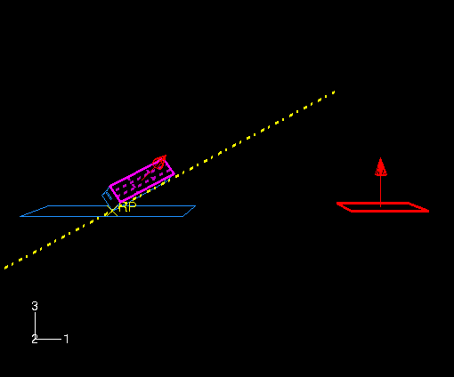
- Instance the circuit board. In the Create Instance dialog box, toggle on Auto-offset from other instances.
- From the main menu bar, select ConstraintParallel Face. Select the face of the board as a face on the movable instance; select a face on the long side of the packaging as a face on the fixed instance. If necessary, click Flip in the prompt area to ensure that the arrows on both faces point in the directions; click OK to complete the constraint.
- From the main menu bar, select ConstraintParallel Edge. Select the top edge of the board as an edge on the movable instance. Select an edge along the length of the packaging as an edge on the fixed instance. If necessary, click Flip in the prompt area to ensure that the arrows on both edges point in the same direction; click OK to complete the constraint.

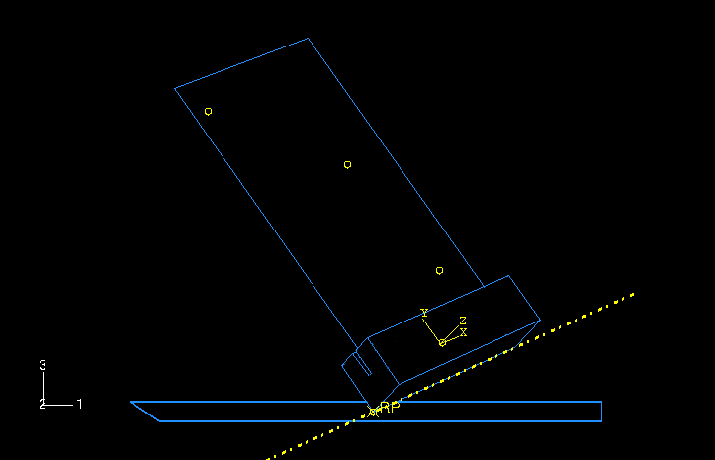
- From the main menu bar, select ConstraintCoincident Point. Select the midpoint of the bottom of the board as a point on the movable instance. Select the datum point at the center of the cut in the packaging as a point on the fixed instance.
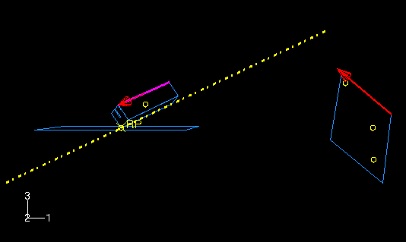

To create the chips:
Create a reference point at each of the three datum point locations on the board to represent each chip. Each of these reference points will later be assigned mass properties. To create a reference point, select ToolsReference Point from the main menu bar of the Assembly module.
Once you have created the reference points, the assembly is complete.
Before continuing, create the following geometry sets that you will use to specify output requests and mass properties:
- TopChip for the reference point of the top chip
- MidChip for the reference point of the middle chip
- BotChip for the reference point of the bottom chip
- BotBoard for the bottom edge of the board
Defining the step and requesting output
Create a single dynamic, explicit step named Drop; set the time period to 0.02 s. Accept the default history and field output requests. In addition, request vertical displacement (U3), velocity (V3), and acceleration (A3) history output every 0.07 × 10^{–3} s for each of the three chips.
Tip: Define the history output request for the first chip; using the History Output Requests Manager, copy the request and edit the domain to define the requests for the other chips.
Request history output every 0.07 × 10^{–3} s for the logarithmic strain components (LE11, LE22, and LE12) and the principal logarithmic strains (LEP) at the top face (section point 5) of the set BotBoard.
Defining contact
Either contact algorithm in ABAQUS/Explicit could be used for this problem. However, the definition of contact using the contact pair algorithm would be more cumbersome since, unlike general contact, the surfaces involved in contact pairs cannot span more than one body. We use the general contact algorithm in this example to demonstrate the simplicity of the contact definition for more complex geometries.
Define a contact interaction property named Fric. In the Edit Contact Property dialog box, select MechanicalTangential Behavior; select Penalty as the friction formulation; and specify a friction coefficient of 0.3 in the table. Accept all other defaults.
Create a General contact (Explicit) interaction named All in the Drop step. In the Edit Interaction dialog box, accept the default selection of All* with self for the Contact Domain to specify self-contact for the default unnamed, all-inclusive surface defined automatically by ABAQUS/Explicit. This is the simplest way to define contact in ABAQUS/Explicit for an entire model. Accept Fric as the Global property assignment, and click OK.
Defining tie constraints
You will use tie constraints to attach the chips to the board. Begin by defining a surface named Board for the circuit board. Select Both sides in the prompt area to specify that the surface is double-sided. In the Model Tree, double-click the Constraints container; define a tie constraint named TopChip. Select Board as the master surface and TopChip as the slave node region. Toggle off Tie rotational DOFs if applicable in the Edit Constraint dialog box since only the effects of the chip masses are of interest, and click OK. Yellow circles appear on the model to represent the constraint. Similarly, create tie constraints named MidChipand BotChip for the middle and bottom chips.
Assigning mass properties to the chips:
You will assign a point mass to each chip. To do this, expand Engineering Features underneath the Assembly container in the Model Tree. In the list that appears, double-click Inertias. In the Create Inertia dialog box, enter the name MassTopChip and click Continue. Select the set TopChip, and assign it a mass of 0.005 kg. Repeat this procedure for the two remaining chips.
Specifying loads and boundary conditions
Constrain the reference point on the floor in all directions; for example, you could prescribe an ENCASTRE boundary condition.
Two methods could be used to simulate the circuit board being dropped from a height of 1 m. You could model the circuit board and foam at a height of 1 m above the floor and allow ABAQUS/Explicit to calculate the motion under the influence of gravity; however, this method is impractical because of the large number of increments required to complete the “free-fall” part of the simulation. The more efficient method is to model the circuit board and packaging in an initial position very close to the surface of the floor (as you have done in this problem) and specify an initial velocity of 4.43 m/s to simulate the 1 m drop. Create a predefined field in the initial step to specify an initial velocity of V3 = –4.43 m/s for the board, chips, and packaging.
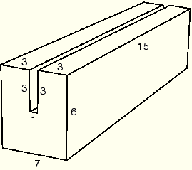
Meshing the model and defining a job
Seed the circuit board with 10 elements along its length and height. Seed the edges of the packaging.
Create a job named Circuit and give it the following description: Circuit board drop test. Double precision should be used for this analysis to minimize the noise in the solution. In the Precision tabbed page of the job editor, select Double as the ABAQUS/Explicit precision. Save your model to a model database file, and submit the job for analysis. Monitor the solution progress; correct any modeling errors that are detected, and investigate the cause of any warning messages.

Postprocessing
Enter the Visualization module, and open the output database file created by this job (Circuit.odb).
Checking material directions
The material directions obtained from the orientation definition can be checked in the Visualization module.
To plot the material orientation:
- First, change the view to a more convenient setting. If it is not visible, display the Views toolbar by selecting ViewToolbarsViews from the main menu bar. In the Views toolbar, select the X–Z setting.
- From the main menu bar, select PlotMaterial OrientationsOn Deformed Shape.
The orientations of the material directions for the circuit board at the end of the simulation are shown. The material directions are drawn in different colors. The material 1-direction is blue, the material 2-direction is yellow, and the 3-direction, if it is present, is red.
- To view the initial material orientation, select ResultStep/Frame. In the Step/Frame dialog box that appears, select Increment 0. Click Apply.
ABAQUS displays the initial material directions.
- To restore the display to the results at the end of the analysis, select the last increment available in the Step/Frame dialog box; and click OK.
Animation of results
You will create a time-history animation of the deformation to help you visualize the motion and deformation of the circuit board and foam packaging during impact.
To create a time-history animation:
- Plot the deformed model shape at the end of the analysis.
- From the main menu bar, select AnimateTime History.
The animation of the deformed model shape begins.
- From the main menu bar, select ViewParallel to turn off perspective.
- In the context bar, click to pause the animation after a full cycle has been completed.
- In the context bar, click and then select a node on the foam packaging near one of the corners that impacts the floor. When you restart the animation the camera will move with the selected node. If you zoom in on the node, it will remain in view throughout the animation.
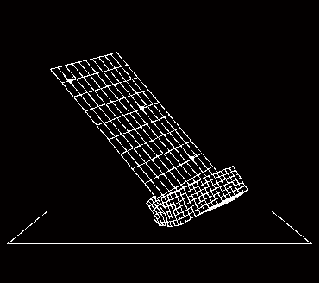
While you view the deformation history of the drop test, take note of when the foam is in contact with the floor. You should observe that the initial impact occurs over the first 4 ms of the analysis. A second impact occurs from about 8 ms to 15 ms. The deformed state of the foam and board at approximately 4 ms after impact is shown below.

Plotting model energy histories
Plot graphs of various energy variables versus time. Energy output can help you evaluate whether an ABAQUS/Explicit simulation is predicting an appropriate response.
To plot energy histories:
- In the Results Tree, click mouse button 3 on History Output for the output database named Circuit.odb. From the menu that appears, select Filter.
- In the filter field, enter *ALL* to restrict the history output to just the energy output variables.
- Select the ALLAE output variable, and save the data as Artificial Energy.
- Select the ALLIE output variable, and save the data as Internal Energy.
- Select the ALLKE output variable, and save the data as Kinetic Energy.
- Select the ALLPD output variable, and save the data as Plastic Dissipation.
- Select the ALLSE output variable, and save the data as Strain Energy.
- In the Results Tree, expand the XYData container.
- Select all five curves. Click mouse button 3, and select Plot from the menu that appears to view the X–Y plot.
Next, you will customize the appearance of the plot; begin by changing the line styles of the curves.
- Open the Curve Options dialog box.
- In this dialog box, apply different line styles and thicknesses to each of the curves displayed in the viewport.
Next, reposition the legend so that it appears inside the plot.
- Double-click the legend to open the Chart Legend Options dialog box.
- In this dialog box, switch to the Area tabbed page, and toggle on Inset.
- In the viewport, drag the legend over the plot.
Now change the format of the X-axis labels.
- In the viewport, double-click the X-axis to access the X Axis options in the Axis Options dialog box.
- In this dialog box, switch to the Axes tabbed page, and select the Engineering label format for the X-axis.
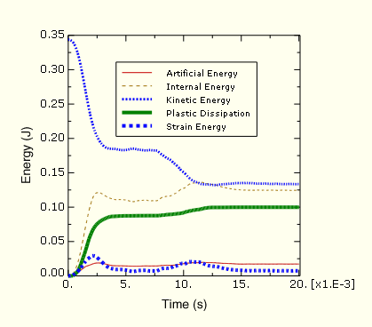

Evaluating acceleration histories at the chips
The next result we wish to examine is the acceleration of the chips attached to the circuit board. Excessive accelerations during impact may damage the chips. Therefore, in order to assess the desirability of the foam packaging, we need to plot the acceleration histories of the three chips. Since we expect the accelerations to be greatest in the 3-direction, we will plot the variable A3.
To plot acceleration histories:
- In the Results Tree, filter the History Output container according to *A3*, select the acceleration A3 of the nodes in sets TopChip, MidChip, and BotChip; and plot the three X–Y data objects.
